

**plant identification (ai)**



**Presented To:**

**Dr. Mohamed Aborizk.**

**Eng. Mohamed Moheb.**

**PRESENTED BY:**

**Salma EL-Sayed 17105510**

**What is classification:**

What is classification? it is the process of categorizing given set of data into classes, it can be performed on structured or unstructured data, process starts with predicting the class of given data points, classes are referred to as target, label of categories, in general compare the characteristic to the data you are trying to classify.

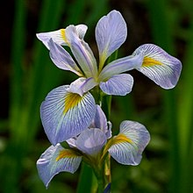

**Introduction**

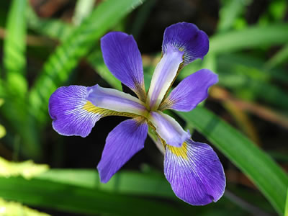

**(Virginia Iris) is a species of perennial herb in the family Iridaceae. They have a self-supporting growth form. They are native to The Contiguous United States, The Contiguous United States, Canada, and Canada. They have simple, broad leaves and blue flowers. Flowers are visited by Two-spotted Skipper, feet.** 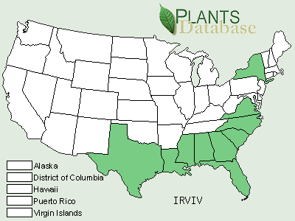

**A southern wetland species occurring from Virginia to Florida and Taxes, Texas, *Iris virginica* is 2 feet (60 cm) tall with bright green leaves that often lie on the ground or water. Southern Blue flag is a member of the iris family (family Iridaceae) which consists of herbs growing from rhizomes, bulbs, or corms, with narrow basal leaves and showy clusters at the tips of long stalks. Flowers: usually radially symmetrical; calyx has 3 petal-like sepals; corolla has 3 petals; stamens 3. All these parts are attached at top of ovary. Leaves: simple, alternate, folded and overlapping one another at the base and aligned in two rows. Fruit: capsule. There are about 60 genera and 1,500 species, distributed in temperate and tropical regions. Among them, Iris, Freesia, Gladiolus, Bugle Lily, and Montbretia are popular ornamentals. Saffron dye is obtained from Crocus, and essence of violets, used in perfumes, is extracted from the rhizomes of Iris.**

**((Description))**

**Iris Family (Iridaceae). Virginia iris is a perennial plant. The slightly fragrant flowers (4 cm long, 7 cm across) consist of 3 horizontal sepals, or “falls,” and 3 erect petals. The petals and sepals can vary in color from dark violet to pinkish white. The sepals have a splash of yellow-to-yellow orange at the crest. Each plant has 2 to 6 flowers that bloom from April to May upon a single, erect, 3-9 dm tall stalk. The stalk is sometimes branched and has a slight zigzag appearance. The plant has 2 to 4 erect or arching, bright green, lance-shaped leaves that are flattened into one plane at the base. Leaves are 1 – 3 cm wide and are sometimes longer than the flower stalk. The fleshy roots (1-2 cm in diameter) are rhizomes that spread underground. Pale brown, variably shaped seeds are born in three-part fruit capsules (3-6 cm long, 1-2 cm wide). Distribution: Virginia iris is common along the coastal plain from Florida to Georgia. For current distribution, please consult the Plant Profile page for this species on the PLANTS Web site.**

**----------------------------------------------------------------------------------------------------------**

**The problem definition**

**Using the classification model to predict the type of the iris flower which will help to make a mobile app to use an air drown to automatic recognize it.**

**DATA ATTRIBUTES**

**1. sepal length in cm**

**2. sepal width in cm**

**3. petal length in cm**

**4. petal width in cm**

**5. class: -**

**- Iris Setosa**

**- Iris Versicolor**

**- Iris Virginica**

**DATA NUMBERING**

**Number of Attributes: 5**

**Number of Instances: 150**

**MODEL DETAIL**

**1-#Read dataset from csv file.**

**2-#check missing values.**

**3-#split data to x, y.**

**4-#SCALE.**

**5-#KNN CLASIFICATION MODEL.**

**6-#CONFUSION MATRIX.**

**7-#ACCURACY CALCULATION.**

**Conclusion:**

**We finally reached the accuracy of 91% of determining the flower type using KN classification model**.